Membership Update – 16th October 2020
Hello everyone,
I hope this update finds you well and that you and yours are all steering well clear of this awful Covid virus which seems to be revisiting us all with increased vigour at the moment.
I know it’s a wee while since I’ve been in touch – I’m sorry about that, but you will be pleased to know that I’ve not been sitting around twiddling my thumbs!! We have been in passport and foal registration mode for much of the last 7 weeks and as we speak just over 200 foals have been registered – but more of that in my next update!
Today I wanted to update you on our 2021 Calendar which is now ready. As with so many other things this year, it has taken a wee bit longer to get this organised, not helped by an un-planned (for them and us) major breakdown in our printer’s printing machine.
But we got there. eventually, and this year’s calendar is ready and is entitled ‘Clydesdales in Lockdown 2020’. Despite the date 2020 in the title, the calendar still says 2021!!
Each year our calendar is a celebration of winners at all the major shows held in the course of the year. As we all know, since going to print last year, only 2 major shows have taken place – our own Winter Fair in November and the Stallion Show in March, a show that just beat lockdown by the skin of its teeth!
So, this year’s calendar celebrates winners at these two shows. But thanks to you, our devoted members and friends, it also incorporates photographs sent in by you for our annual competition sponsored by Shona Harrison in memory of the late John Zawadski. This year the winners of that competition were:
- Val Smith
- Claire Myers
- Desi Hill
Val’s photo takes pride of place on the front cover and Claire and Desi’s entries feature inside along with a number of ‘highly commended’ photos supplied by you.
The inside front cover of the calendar features the winners in our Young People Photograph Competition which was keenly contested and won by Fiona Craig, with Sophie Mitchell and Miles Chester taking runner up spots.
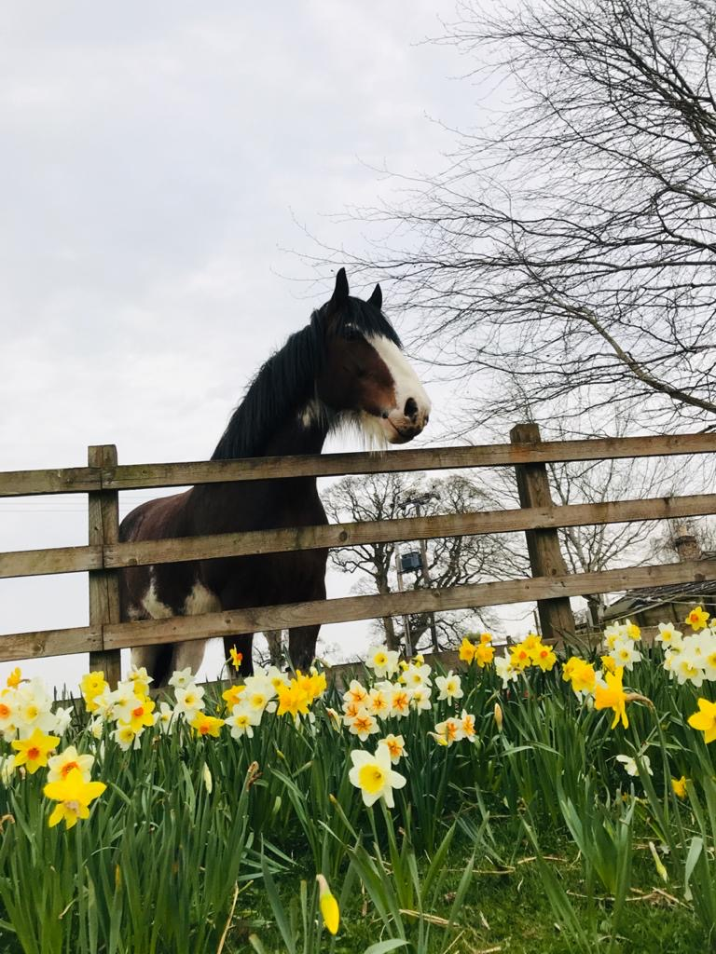
Val Smith’s Winning Photograph
All the photos entered into our competition are on a separate page on our website (www.clydesdalehorsesociety.com) – in the section entitled 2020 Gallery and the junior photos are to be found on 2020 Junior Gallery.
On the basis that ‘you can never please everyone all the time’ I know that for the purist this may not be your chosen format of Calendar but we have striven to do the best we could in what has been a difficult year.
I am disappointed that this year I won’t be seeing any of you at the end of year shows and consequently taking the opportunity to purloin a shekel or two from you for your copy of the 2021 Calendar! But I would be delighted to send a copy to you direct to your home address.
All you have to do is cross my palm with £12 in cash or by cheque, sent to the office, and your Calendar will be in the post back to you by return. Or alternatively transfer £12 per copy to our bank account and a similar speed of despatch will follow.
Here are our bank details for ease of reference.
Bank of Scotland
Sort Code: 80 02 78
Account number: 00604757
IBAN: GB44 BOFS 8002 7800 6047 57
BIC: BOFS GB21347

A reminder too about our 2020 raffle and the deadline for submission of Raffle Tickets which remains in advance of 21st November 2020, on which date the draw must legally be made. With the postponement of the Winter Fair, the logistics of that draw will need to be worked through, but it will happen. I can send raffle tickets to anyone who would like to have them!
Both the proceeds from the sale of our calendar and any surplus from the annual raffle makes an important contribution to our annual fundraising and I hope you will feel able to support us, particularly this year.
I will be back in touch in the weeks ahead – maybe not a frequently as weekly as was the case during the earlier lockdown but you will hear from me, like it or not!!!
All the very best to you all – stay safe – stay well – and be as good as you feel you have to be!!!

