PRIZE MONEY  SENIORS  1ST £30 2ND £20 3RD £10 4TH£5  FOALS  1ST £40 2ND £30 3RD£25 4TH£20 5TH £10  TROPHY WINNERS 2020  LAST YEARS TROPHY WINNERS ARE  REMINDED TO RETURN TROPHIES TO  THE SHOW SECTETARY  NO LATER THAN 9.30AM ON SHOW DAY.  THANK YOU.  ENTRIES  ENTRY CLOSING DATE WEDNESDAY 5TH JANUARY 2022  ENTRIES PREFERRED BY EMAIL BUT POST ACCEPTED |  |  | Kilpatrick Foal Show  111th Annual Foal Show  to be held at Ayr Cattle Market  by Kind permission of  Messers. Craig Wilson ltd, Whitefordhill,Ayr  Saturday 8th January 2022  Judging at 11am prompt  Judge:- Mr Sandy Aitken, Forfar  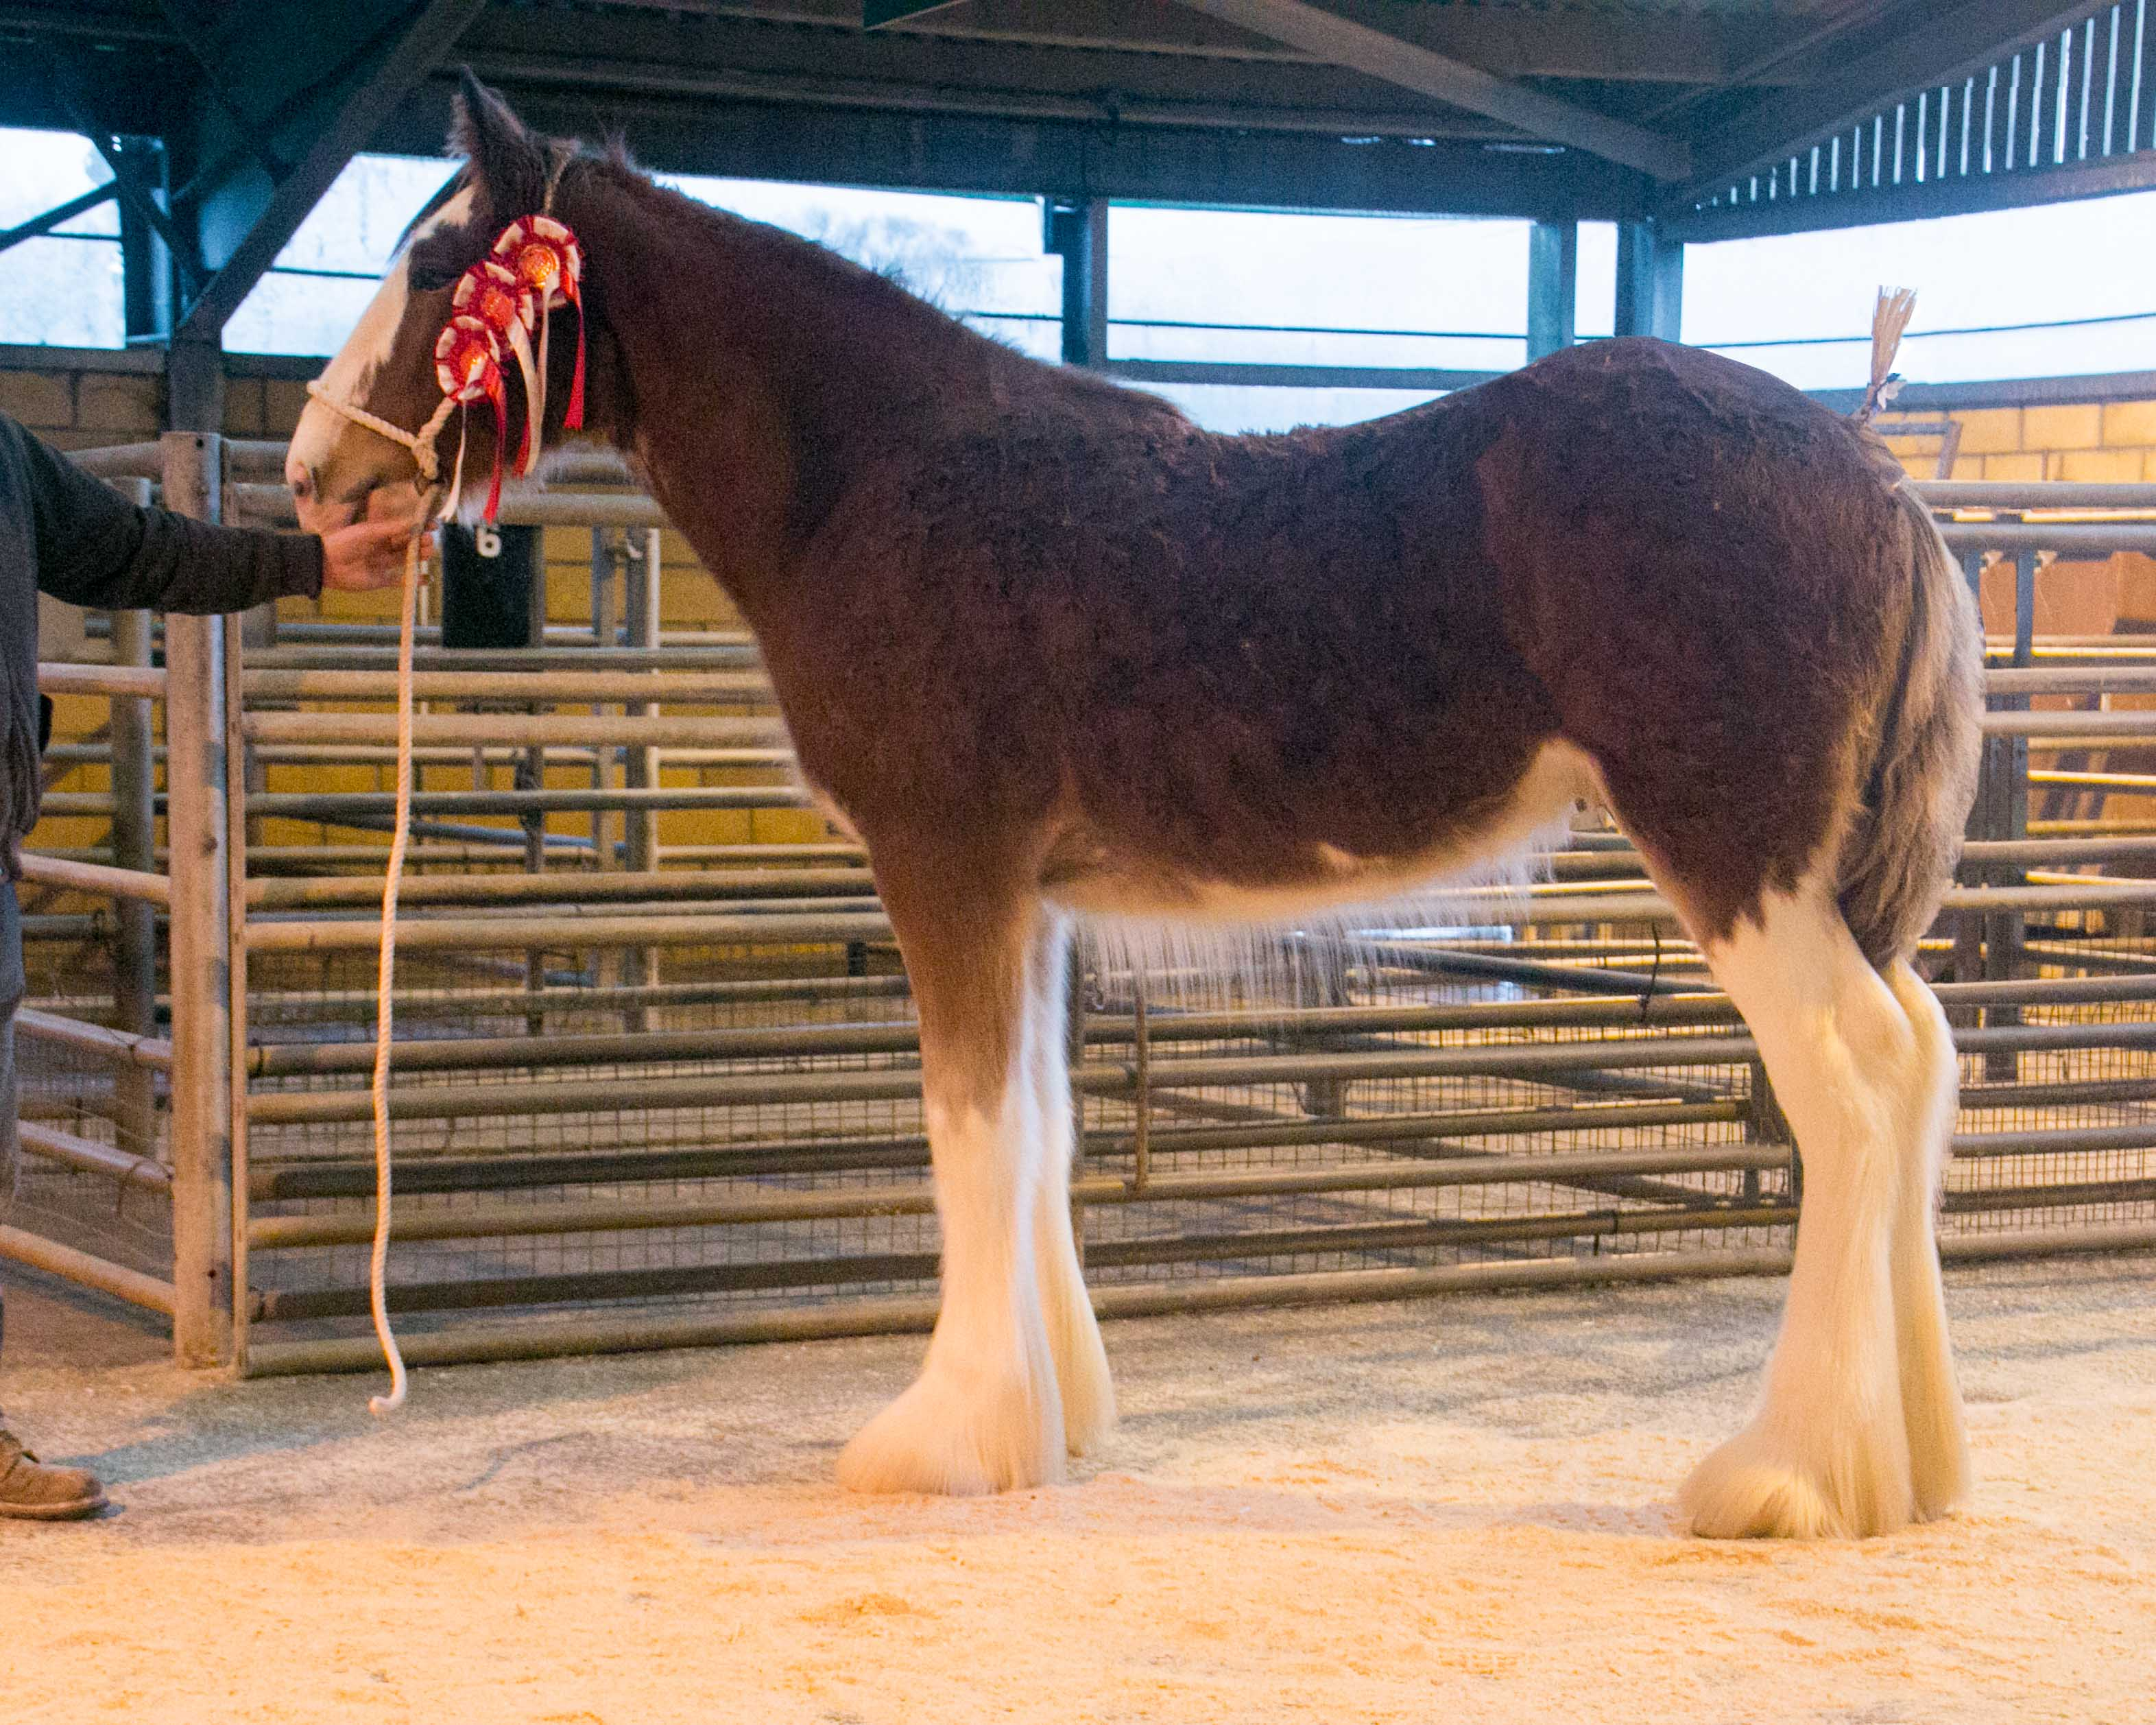  - Secretary :- Miss Amanda Stewart,  34 Badenheath Terrace, Mollinburn, Cumbernauld, G67 4HL  Mobile:- 07534578998 email:-kilpatrickfoalshow@gmail.com  3

CLASS LIST  SENIOR SECTION  - MARE OR GELDING 3 YEARS AND OVER  - COLT OR GELDING 2 YEARS OLD  - FILLY 2 YEARS OLD  - COLT OR GELDING 1 YEAR OLD  - FILLY 1 YEAR OLD  FOAL SECTION  - COLT FOAL BORN BEFORE 1ST May, 2021  - COLT FOAL BORN ON OR AFTER 1ST May, 2021  8. FILLY FOAL BORN BEFORE 1ST May, 2021  9. FILLY FOAL BORN ON OR AFTER 1ST May, 2021 |  | SPECIAL CLASSES  OVERALL SENIOR CHAMPION :-  JAMES CLARK MEMORIAL CUP  BEST FOAL IN SHOW :-  MCFARLANE CUP  BEST SENIOR FOAL FROM CLASSES 6&8  GEORGE SMITH TROPHY  BEST JUNIOR FOAL FROM CLASSES 7&9 -  JAMES PETTIGREW CUP  BEST FILLY FOAL  GEORGE SMITH TROPHY  BEST FOAL BRED:-  CARSLAW CUP  BEST FEMALE CONFINED:-  MRS MCLACHLAN TROPHY  BEST MALE CONFINED:-  FRASER CUP  OVERALL CHAMPION:-  LORD FRASER CUP  RESERVE CHAMPION:-  JAMES CLARK CUP  BEST COLT OR FILLY FOAL OFF ANY OF JAMES YOUNG’S  STUD HORSES  BEST PRESENTED HORSE

ENTRY FORM

COMPLETE FORM BY WEDNESDAY 5TH JANUARY 2022 TO BE INCLUDED IN THE CATALOUGE AND RETURN TO:-
MISS AMANDA STEWART, 34 BADENHEATH TERRACE, MOLLINBURN,CUMBERNAULD, GLASGOW, G67 4HL
OR EMAIL TO kilpatrickfoalshow@gmail.com
PLEASE COMPLETE USING BLOCK CAPITALS
ENTRY FEE £5 PER HORSE AND £10 PER HORSE IF ENTERED AFTER 5TH JANUARY
CLASS NUMBER | NAME OF ENTRY | DOB | SIRE | DAM | ENTRY FEE
NAME :- __________________________________________________________________________________________________________  ADDRESS:- ________________________________________________________________________________________________________  _____________________________________________________________________________________________________________________  CONTACT NUMBER ______________________________________________________________________________________________  PLEASE CIRCLE HOW YOU WOULD LIKE TO PAY :- CASH / CHEQUE |  |  |  | TOTAL ENTRY FEE
 |  |  |  | FIRST AID | £2
 |  |  |  | TOTAL COST
PLEASE MAKE CHEQUES PAYABLE TO:- THE KILPATICK FOAL SHOW

