PRIZE MONEY  SENIORS  1ST £30 2ND £20 3RD £10 4TH£5  FOALS  1ST £40 2ND £30 3RD£25 4TH£20 5TH £1  TROPHY WINNERS 2023  LAST YEARS TROPHY WINNERS ARE  REMINDED TO RETURN TROPHIES TO  THE SHOW SECTETARY  NO LATER THAN 9.30AM ON SHOW DAY.  THANK YOU.  ENTRIES  ENTRY CLOSING DATE SUNDAY 7 ^{TH} JANUARY 2024  ENTRIES PREFERRED BY EMAIL BUT POST ACCEPTED  ENTIES ACCEPTED ON THE DAY (WILL BE CHARGE AT DOUBLE ENTRY FEE) |  |  | Kilpatrick Foal Show  113th Annual Foal Show  to be held at Ayr Cattle Market  by Kind permission of  Messers. Craig Wilson ltd, Whitefordhill,Ayr  Saturday 13th January 2024  Judging at 11am prompt  Judge:- Annette Noble, Peggyslea  - 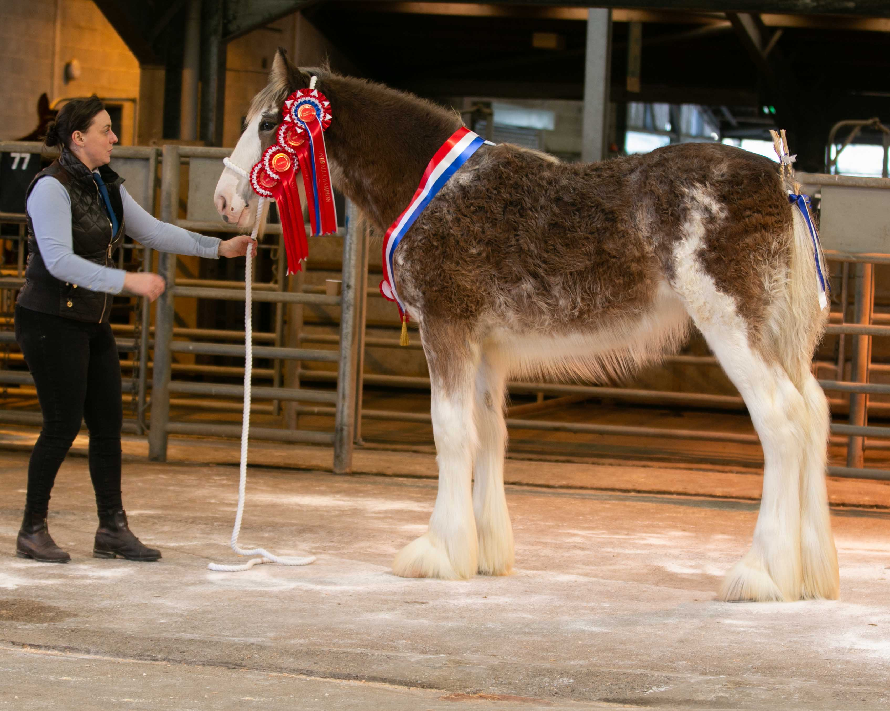  - Secretary :- Miss Amanda Stewart,  Mollinhillhead Farm, Mollinsburn, Cumbernauld, Glasgow, G67 4HR  Mobile:- 07534578998 email:-kilpatrickfoalshow@gmail.com  3

CLASS LIST  SENIOR SECTION  - MARE OR GELDING 3 YEARS AND OVER  - COLT OR GELDING 2 YEARS OLD  - FILLY 2 YEARS OLD  - COLT OR GELDING 1 YEAR OLD  - FILLY 1 YEAR OLD  FOAL SECTION  - COLT FOAL BORN BEFORE 1ST May, 2023  - COLT FOAL BORN ON OR AFTER 1ST May, 2023  8. FILLY FOAL BORN BEFORE 1ST May, 2023  9. FILLY FOAL BORN ON OR AFTER 1ST May, 2023 |  | SPECIAL CLASSES  OVERALL SENIOR CHAMPION :-  JAMES CLARK MEMORIAL CUP  BEST FOAL IN SHOW :-  MCFARLANE CUP  BEST SENIOR FOAL FROM CLASSES 6&8  GEORGE SMITH TROPHY  BEST JUNIOR FOAL FROM CLASSES 7&9 -  JAMES PETTIGREW CUP  BEST FILLY FOAL  GEORGE SMITH TROPHY  BEST FOAL BRED:-  CARSLAW CUP  BEST FEMALE CONFINED:-  MRS MCLACHLAN TROPHY  BEST MALE CONFINED:-  FRASER CUP  OVERALL CHAMPION:-  LORD FRASER CUP  RESERVE CHAMPION:-  JAMES CLARK CUP  BBEST COLT OR FILLY FOAL OFF ANY OF JAMES YOUNG’S  STUD HORSES  BEST PRESENTED HORSE

ENTRY FORM

COMPLETE FORM BY SUNDAY 7th January 2023 TO BE INCLUDED IN THE CATALOUGE AND RETURN TO:-
EMAIL:- KILPATRICKFOALSHOW@GMAIL.COM OR
POST MIISS AMANDA STEWART, MOLLINHILLHEAD FARM, MOLLINSBURN, CUMBERNAULD, GLASGOW, G67 4HR
PLEASE COMPLETE USING BLOCK CAPITALS
ENTRY FEE £5 PER HORSE AND £10 PER HORSE IF ENTERED AFTER 7th JANUARY
CLASS NUMBER | NAME OF ENTRY | DOB | SIRE | DAM | ENTRY FEE
NAME :- __________________________________________________________________________________________________________  ADDRESS:- ________________________________________________________________________________________________________  _____________________________________________________________________________________________________________________  CONTACT NUMBER ______________________________________________________________________________________________  PLEASE CIRCLE HOW YOU WOULD LIKE TO PAY :- CASH / CHEQUE |  |  |  | TOTAL ENTRY FEE
 |  |  |  | FIRST AID | £2
 |  |  |  | TOTAL COST
PLEASE MAKE CHEQUES PAYABLE TO:- KILPATICK FOAL SHOW

