  PRIZE MONEY
  SENIORS
  1ST £30 2ND £20 3RD £10 4TH£5
  FOALS
  1ST £40 2ND £30 3RD£25 4TH£20 5TH £15
  TROPHY WINNERS 2025
  LAST YEARS TROPHY WINNERS ARE
  REMINDED TO RETURN TROPHIES TO
  THE SHOW SECTETARY
  NO LATER THAN 9.30AM ON SHOW DAY.
  THANK YOU.
  ENTRIES
  ENTRY CLOSING DATE MONDAY 5TH JANUARY 2026
  ENTRIES PREFERRED BY EMAIL BUT POST ACCEPTED
  ENTIES ACCEPTED ON THE DAY (WILL BE CHARGE AT £15 PER ENTRY FEE)
  Kilpatrick Foal Show
  115th Annual Foal Show
  to be held at Ayr Cattle Market
  by Kind permission of
  Messers. Craig Wilson ltd, Whitefordhill,Ayr
  Saturday 10th January 2026
  Judging at 11am prompt
  Judge:- Mairi Barr, Eaglesham
    - 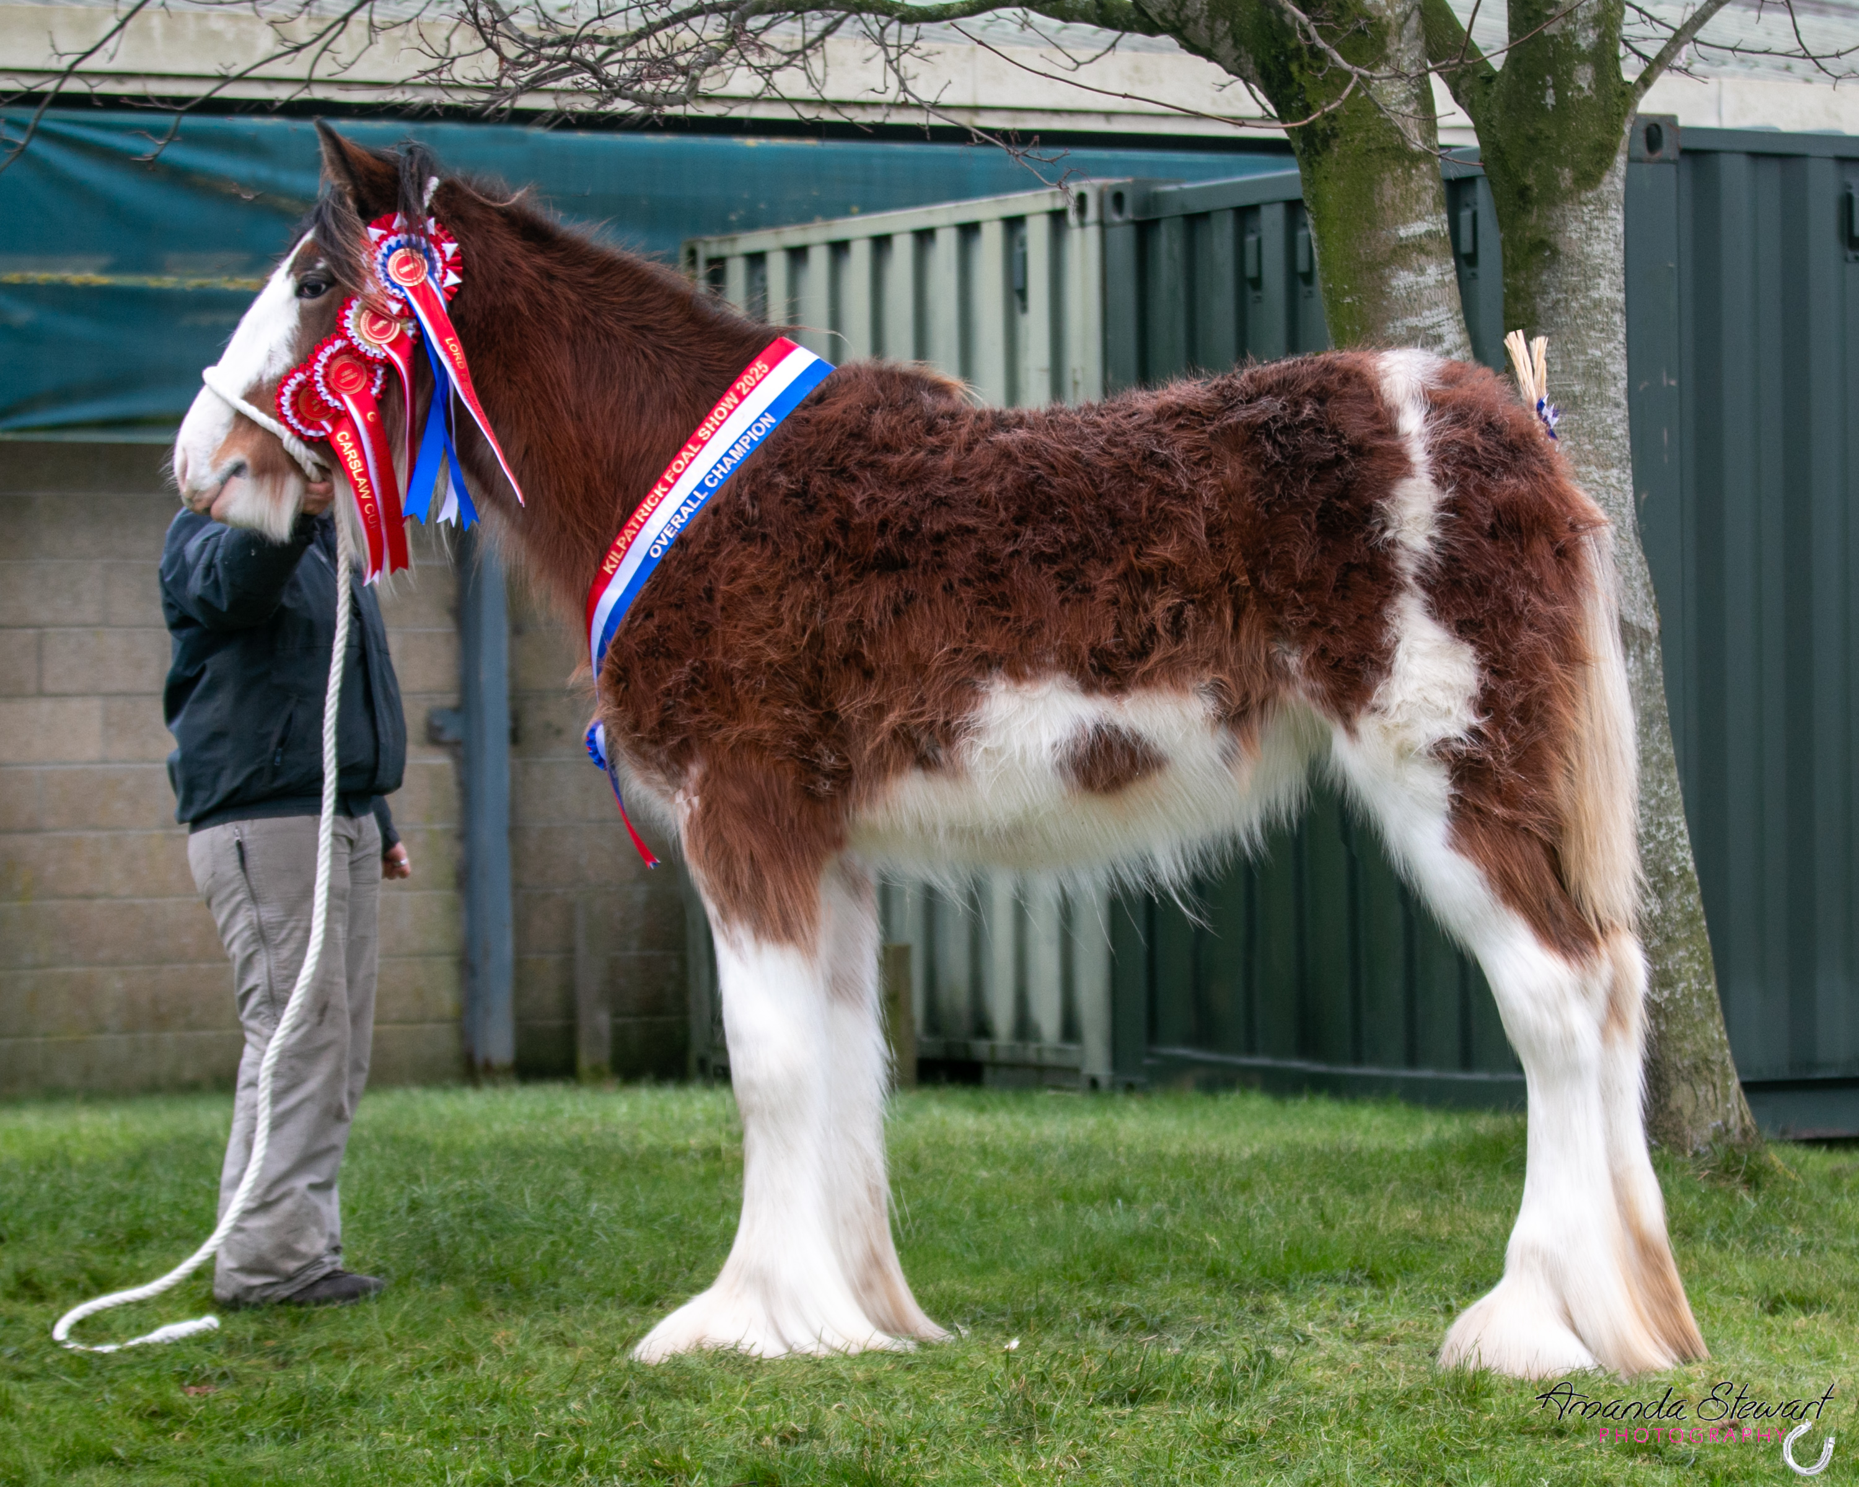
    - Photo Champion 2025:- Herkules Texas Hold’em, C.Paulsson
    - Secretary :- Miss Amanda Stewart,
  Mollinhillhead Farm, Mollinsburn, Cumbernauld, Glasgow, G67 4HR
  Mobile:- 07534578998 email:-kilpatrickfoalshow@gmail.com
  3

CLASS LIST  SENIOR SECTION  - MARE OR GELDING 3 YEARS AND OVER  - COLT OR GELDING 2 YEARS OLD  - FILLY 2 YEARS OLD  - COLT OR GELDING 1 YEAR OLD  - FILLY 1 YEAR OLD  FOAL SECTION  - COLT FOAL BORN BEFORE 1ST May, 2025  - COLT FOAL BORN ON OR AFTER 1ST May, 2025  8. FILLY FOAL BORN BEFORE 1ST May, 2025  9. FILLY FOAL BORN ON OR AFTER 1ST May, 2025 |  | SPECIAL CLASSES  OVERALL SENIOR CHAMPION :-  JAMES CLARK MEMORIAL CUP  BEST FOAL IN SHOW :-  MCFARLANE CUP  BEST SENIOR FOAL FROM CLASSES 6&8  GEORGE SMITH TROPHY  BEST JUNIOR FOAL FROM CLASSES 7&9 -  JAMES PETTIGREW CUP  BEST FILLY FOAL  GEORGE SMITH TROPHY  BEST FOAL BRED:-  CARSLAW CUP  BEST FEMALE CONFINED:-  MRS MCLACHLAN TROPHY  BEST MALE CONFINED:-  FRASER CUP  OVERALL CHAMPION:-  LORD FRASER CUP  RESERVE CHAMPION:-  JAMES CLARK CUP  BBEST COLT OR FILLY FOAL OFF ANY OF JAMES YOUNG’S  STUD HORSES  BEST PRESENTED HORSE

ENTRY FORM

COMPLETE FORM BY MONDAY 5TH January 2026 TO BE INCLUDED IN THE CATALOUGE AND RETURN TO:-
EMAIL:- KILPATRICKFOALSHOW@GMAIL.COM OR
POST MIISS AMANDA STEWART, MOLLINHILLHEAD FARM, MOLLINSBURN, CUMBERNAULD, GLASGOW, G67 4HR
PLEASE COMPLETE USING BLOCK CAPITALS
ENTRY FEE £10 PER HORSE AND £15 PER HORSE IF ENTERED AFTER 5th JANUARY
CLASS NUMBER | NAME OF ENTRY | DOB | SIRE | DAM | ENTRY FEE
NAME :- __________________________________________________________________________________________________________  ADDRESS:- ________________________________________________________________________________________________________  _____________________________________________________________________________________________________________________  CONTACT NUMBER ______________________________________________________________________________________________  PLEASE CIRCLE HOW YOU WOULD LIKE TO PAY :- CASH / CHEQUE / BACS |  |  |  | TOTAL ENTRY FEE
 |  |  |  | TOTAL COST
PLEASE MAKE CHEQUES PAYABLE TO:- KILPATICK FOAL SHOW

PLEASE REMEMBER TO BRING HORSE PASSPORTS TO THE EVENT AS PER THE SCOTTISH GOVERNMENT

