THE CLYDESDALE HORSE SOCIETY WINTER FAIR
Kindly Supported by the legacy of the late Gerald Fallowes
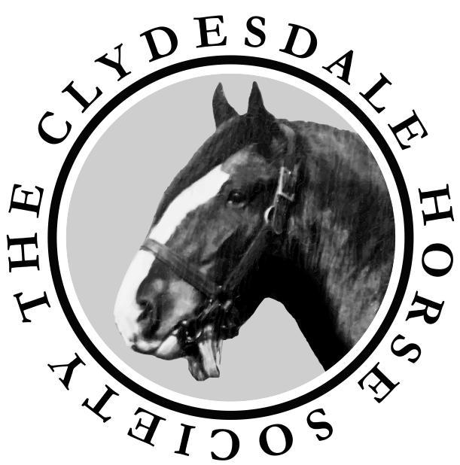

Patron – HRH The Prince of Wales

www.clydesdalehorsesociety.com

LANARK AGRICULTURAL CENTRE

SATURDAY 30th NOVEMBER 2019

Judge
Mr Walt Bedford, Sheepwalk Farm, York

Champion of Champions Judge
Mr Hugh Ramsay, Millisle Farm, Newton Stewart

Judging commences at 10.45am

President: Mr James Rochead
Vice President: Mr Alasdair Fletcher
Immediate Past President: Mr Peter Keron
Hon Treasurer: Captain James Anderson

Secretary: Ian A Roy BA
7 Turretbank Place, Crieff, PH7 4LS
Tel: 07720 895870
Email: secretary@clydesdalehorsesociety.com
Schedule of Classes

- Novice Handler – for those aged over 16 to be judged on handler’s performance only; horse used must be entered in an in-hand class.
- Gelding born in or before 2016.
- Mare or filly born in or before 2016.
- Filly born in 2017.
- Colt or gelding born in 2017 or 2018.
- Filly born in 2018.
- Senior colt foal born on or before 30/4/2019.
- Senior filly foal born on or before 30/4/2019.
- Junior colt foal born on or after 1/5/2019
- Junior filly foal born on or after 1/5/2019
- Pair of foals by the same sire - entry on the day.
- Young Handlers Class for those aged 12 – 16 on the day of the Show (run under CHS rules). Qualifier for Young Handler Final 2020.

- Champion of Champions Class

Entry Fees
Class 1 - no fee
Classes 2 to 10 - £10 per entry
Classes 11 and 12 - no fee
Class 13 - £10 per entry

Prize money
Overall Champion - £100
Reserve Overall Champion - £50

Classes 2 – 10
1st £50
2nd £40
3rd £30
4th £20
5th £15
6th £10

Class 12
CHS rosettes and a memento to all competitors

Class 13 - Champion of Champions
Champion - £100
Reserve Champion - £50

Judging to start at 10.45 am with the novice handler class.
Class 2 will not commence before 11 am

Trophies

Peter Sharp Perpetual Challenge Trophy
Overall Champion

The Hillhouse Silver Shadow Memorial Trophy
Reserve Champion

The Paul L Cooper Perpetual Challenge Trophy
Best Foal

The George Robertson Trophy
Best Foal Bred by Exhibitor

The Kildean Perpetual Challenge Trophy
Best Animal Bred by Exhibitor

The Jackton Trophy
Best Senior Horse

The Macfin Perpetual Silver Salver
Best Horse of opposite sex to the Overall Champion

The Manuel Trophy
Best One or Two Year Old

The Auchengree Clydesdales Trophy
Presented by Matthew Burks and Jacqueline Pettigrew
Best Young Handler

Rules and Regulations for the Clydesdale Horse Society Winter Fair

Disclaimer of Liability to Exhibitors
- The Clydesdale Horse Society shall disclaim liability for the death or personal injury caused by the negligence of the Society, its servants or agents, or any person whilst entering or leaving the Showground. The Society shall not be responsible for death, injury, disease or loss caused to any exhibitor or by any vehicle brought by the exhibitor to the showground or car park. Acceptance of the foregoing is a condition of entry. Exhibitors are advised to insure against fire and other appropriate risk as regards their own property and against third party claims.

Entries
- Entry fees are as stated. The correct fee must be remitted with the entry form or entries will not be accepted. No refunds will be given.
- The Society reserves the right to refuse entry and return the entry fee to any person.
- Horses exhibited must be owned by the named exhibitor at the date of closure of entries and the horse passport must reflect that ownership. Entry forms must be signed by that owner/exhibitor. All owners/exhibitors must be current members of The Clydesdale Horse Society. All mares and stallions must be registered and in the case of fillies be in the process of being registered with The Clydesdale Horse Society at the entry closing date. Colts and geldings must be entered as Produce or be in the process of being entered as Produce with the Society. Horses entered in the Grade-Up Appendix, Colts out of a Grade-Up mare or horses of unknown pedigree are not eligible to compete.
- Exhibitors are solely responsible for the accuracy and eligibility of their entries. Exhibitors must prove the correctness of their entries if required to do so by stewards.

Protests
- All protests must be made in writing to the Secretary of the Society before 4pm on the day of the Show. This must be accompanied with a £50 deposit which will be returned if the protest is upheld. The protest will be considered by the Executive Committee of the Clydesdale Horse Society in consultation with stewards.

Disqualification
- The Chief Steward has the power to disqualify any entry. There is no appeal against any disqualification made by the Chief Steward or by the Judge.

Mode of Dress
- Handlers should wear a shirt and Clydesdale Horse Society tie. White coats MUST be worn in the ring.
Rules and Regulations for the Clydesdale Horse Society Winter Fair

Number of Attendants in the Ring
- Only two persons will be permitted in the ring with each horse, namely the person leading the horse and one attendant for dressing out purposes.

Champion of Champions Class
- Starting on 1 January 2019, the champion Clydesdale from each show affiliated to the Clydesdale Horse Society in 2019 will be eligible to enter. The 2019 Champion of Champions class will also be open to the Champions from the Grampian Foal Show and the County Londonderry, Horse Breeders Clydesdale Show, both held in December 2018.The competition will be open to all champions including geldings.

If the champion at any local affiliated show has already qualified, the reserve champion at that show will not be eligible to enter.

There will be an entry fee of £10 per entry and any exhibitor can qualify as many horses as they want but a horse can only qualify once a year.

Equine Flu
The Clydesdale Horse Society’s current position with regard to recent incidences of Equine Flu is noted below and the following guidelines should be adhered to.

We will not routinely examine passports for evidence of flu vaccinations but all passports should be brought to the Winter Fair. All horses exhibiting must be fit and well and showing no signs of illness on the day of the Winter Fair. Further, any horse which has shown signs of illness within the 10 days prior to the event should not be brought to the event.
We expect all competitors to practice good, sensible bio-security measures in terms of sharing of equipment, buckets, etc with other horses, maintain a sensible space away from all other horses and prevent horses from sniffing noses.
If new cases of Equine Flu are discovered prior to the event these practices may require to change and the Clydesdale Horse Society reserves the right to have a veterinary surgeon on site on the day of the event to inspect horses unloading and to adjudicate on the fitness or otherwise of a horse to be shown. That veterinary surgeon’s decision concerning the fitness of any horse for exhibiting will be final.

At the present time the approach being taken is that the risk of equine flu is no higher than at any other time – these guidelines should, therefore, be seen as being a general precautionary measure.

We respectfully ask all exhibitors to use a common-sense approach.

